Main entry screen
Boxes across top are: Clerk initials, Transaction number, (cannot be edited), quanity, price.

Clerk enters initial, box autofills, presses enter, cursor goes to center box where barcode is scanned in or rx number is entered if no barcode on receipt. If match for code or rx number is found cursor goes to price which is highlighted allowing edit if necessary. Press enter and item is added to line in center of screen.

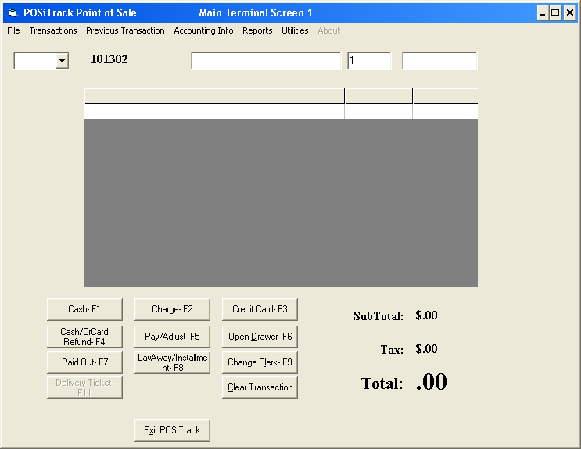

Several prescriptions have been entered, total is displayed and ready for customer to tell you what kind of transaction it is- cash, charge, credit card etc.

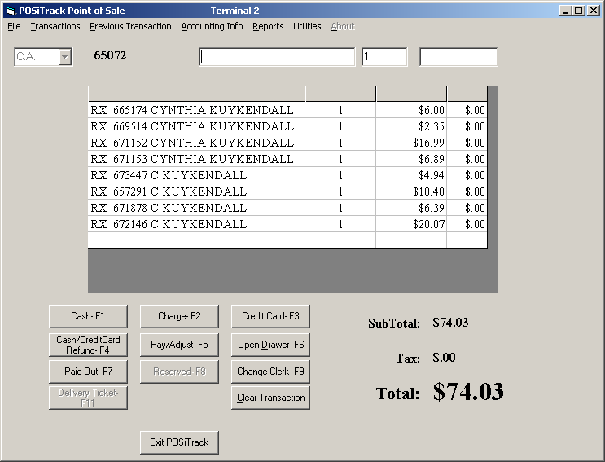

F1, F2, or F3 is pressed for transaction type. If a filled prescription has been missed or there is one in the will call bin the following screen will appear for review.

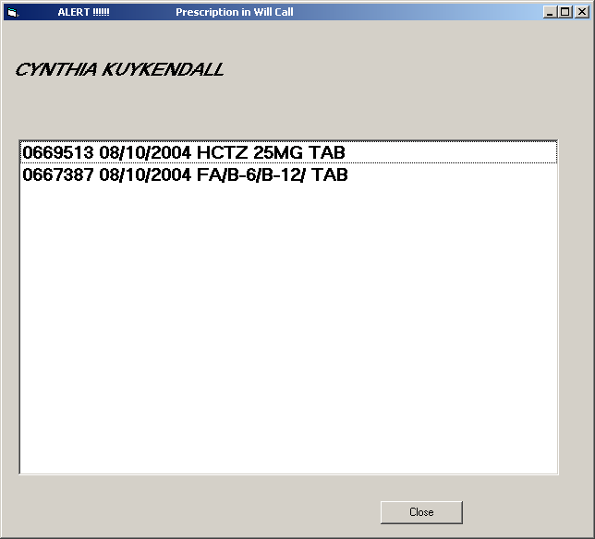

You can note the above screen, check the will call bin or see if you missed a receipt when ringing up the sale. This screen will automatically close when the transaction is over or can be closed with the close button.

In this example, F2 is pressed for charge sale, screen on transaction terminal (and computer) displays the signature log.

If one of the patients had not yet signed a HIPAA notice, the HIPAA notice with their name on it would automatically print out from the receipt printer and a screen would appear for their signature. The HIPAA signature must be separate from other signatures.

After signing the HIPAA screen the transaction moves on to the signature log.

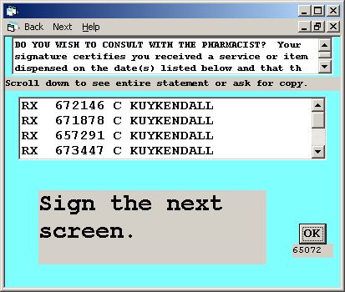

If this were a cash sale the customer would sign this screen for the signature log, but in order having to sign multiple times the customer signs the next screen authorizing both the signature log and the charge transaction.

On charge transactions that include a prescription the following screen appears with the head of household belonging to the last prescription rung up. If this is the account to be charged- press enter. If not, enter the name of the person or entity to be charged.

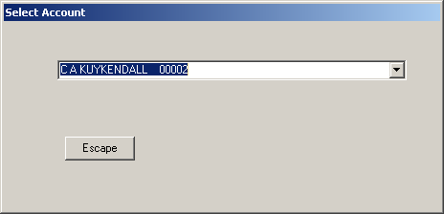

This screen appears on the computer and the terminal displaying name and address of person to be charged, account balances, current transaction amount and new balance.

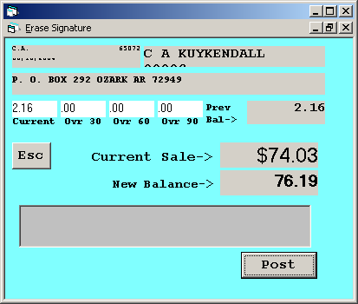

This form appears over the above form is notes are present for the customer.
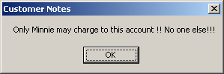

This form appears if there has been no charge activity for this customer. The program WILL allow you to continue with the charge transaction. (In case it is a new account you want to open)
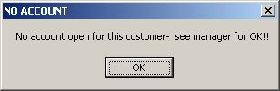

This form appears if you have indicated no charges for this customer. The program WILL NOT allow a charge to be posted until you manually edit the patient record.
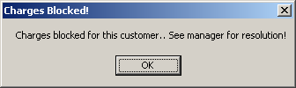

Similar message boxes appear to alert for over 60 and over 90 balances, with the option to not allow further charges to be posted if there is a balance over 90. To prevent further charges the patient record must be edited for no charges.

When transaction is complete all posting is done. No further posting and adding up charge tickets is required.

Press F5 on main screen to view patient account or post charges or adjustments.

This allows for multiple forms of tender. Credit card payments may NOT be mixed with other forms of tender.
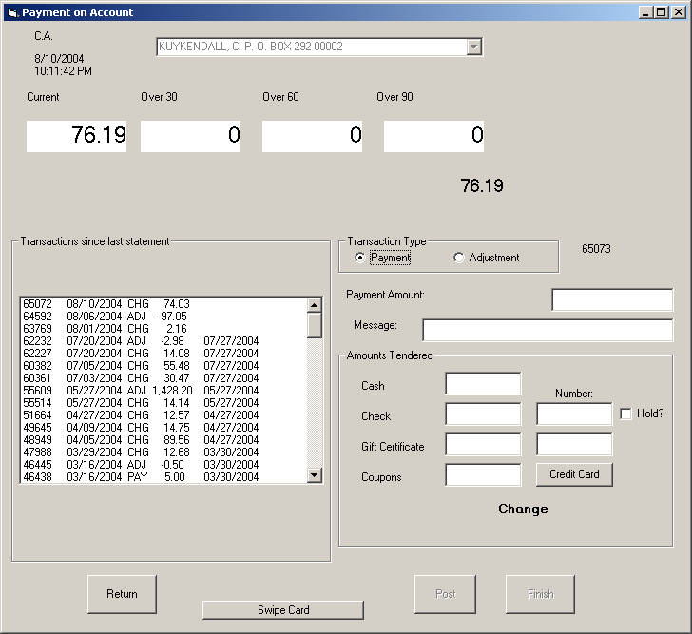

The list box on the left displays most recent transactions with transaction number, date, type, amount, statement date. To view an individual transaction double click on that line in the list box.

Double-clicking on a transaction on the payment form displays the transaction detail on the computer and on the terminal. The signature appears on the terminal.
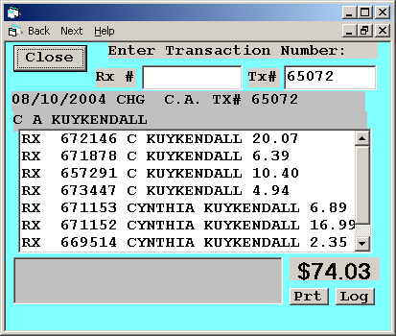

Clicking on the Prt button will produce a reprinted ticket with signature. (Signature not displayed in this example)
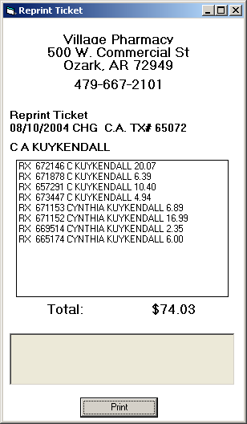

Allows you to show who picked up a prescription or made a charge.

Clicking on Log will display a form that can be printed if signature log documentation is required.
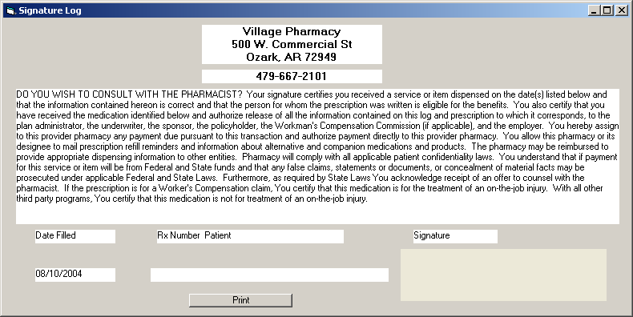

Credit card transactions are done on same terminal.
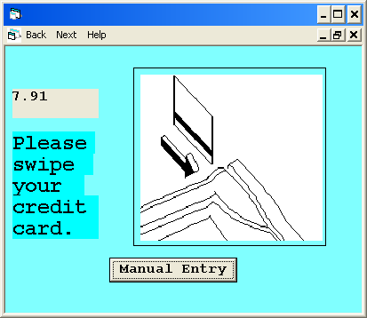

After checking out a summary of the days transactions may be displayed.

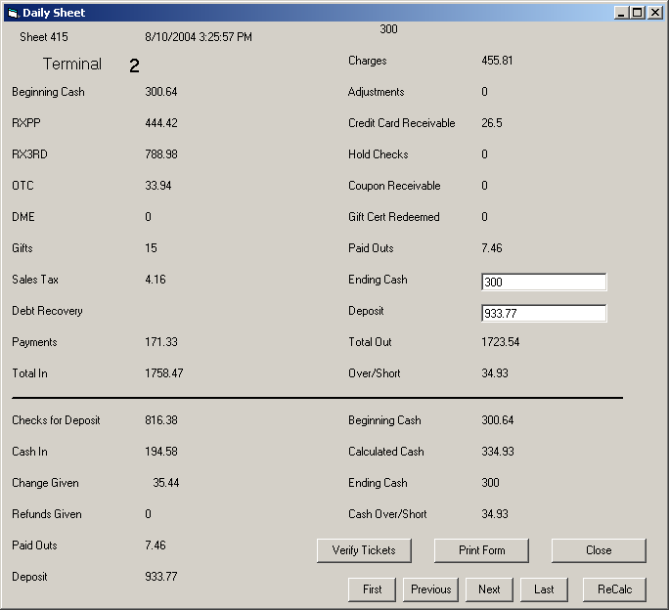

Lay Away Module allows easy tracking of sales.

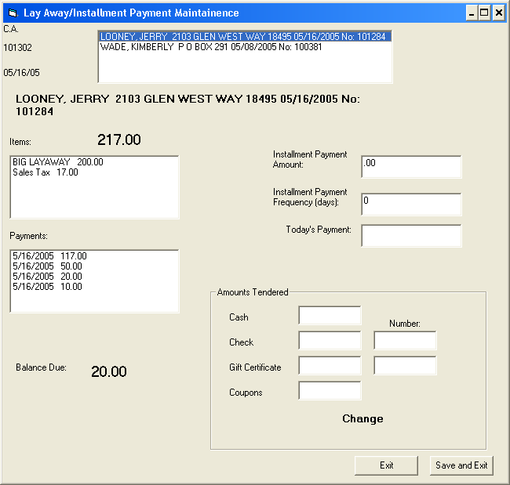

Signature log for Pseudoephedrine containing products
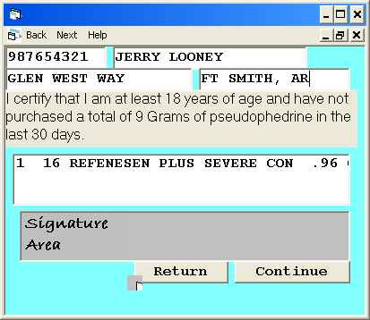

Pop up shows previous 30 day sales
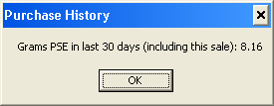

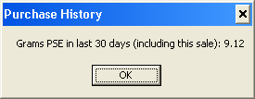

Sale blocked if over limit (9Gm in 30 days- Arkansas)
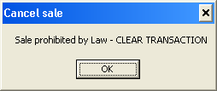

Form shows sales by date or driver license number

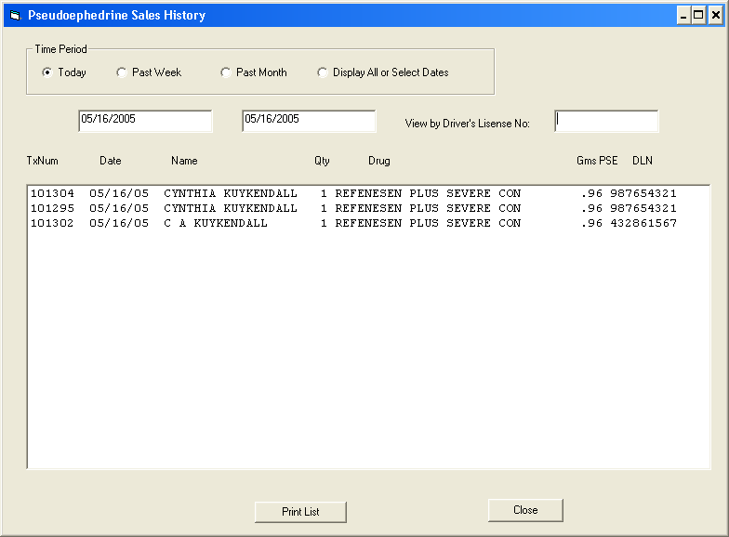

If customer attempts to put this sale on his Medical Savings Account card-

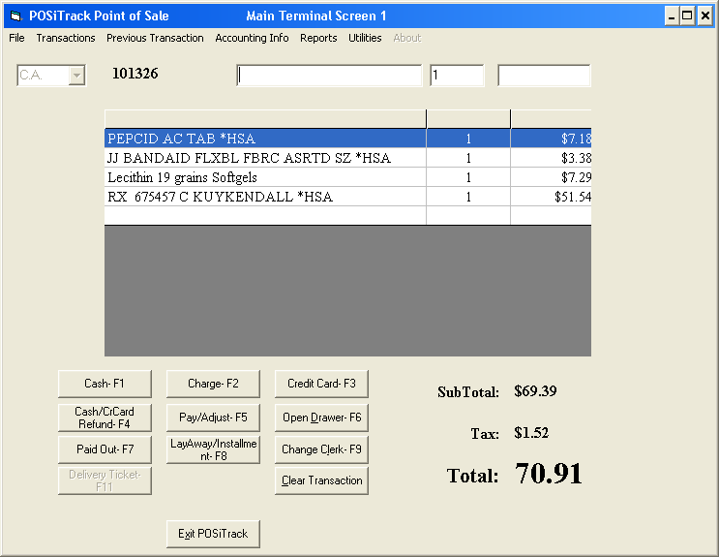

This message box pops up and does not allow the transaction.

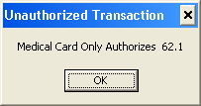

Other reports include UNCLAIMED PRESCRIPTIONS- (filled but not picked up).

Third party claims that were paid at 100% to help identify underbilling.

